Activity 4- Informatica Project:

DB:

Source:

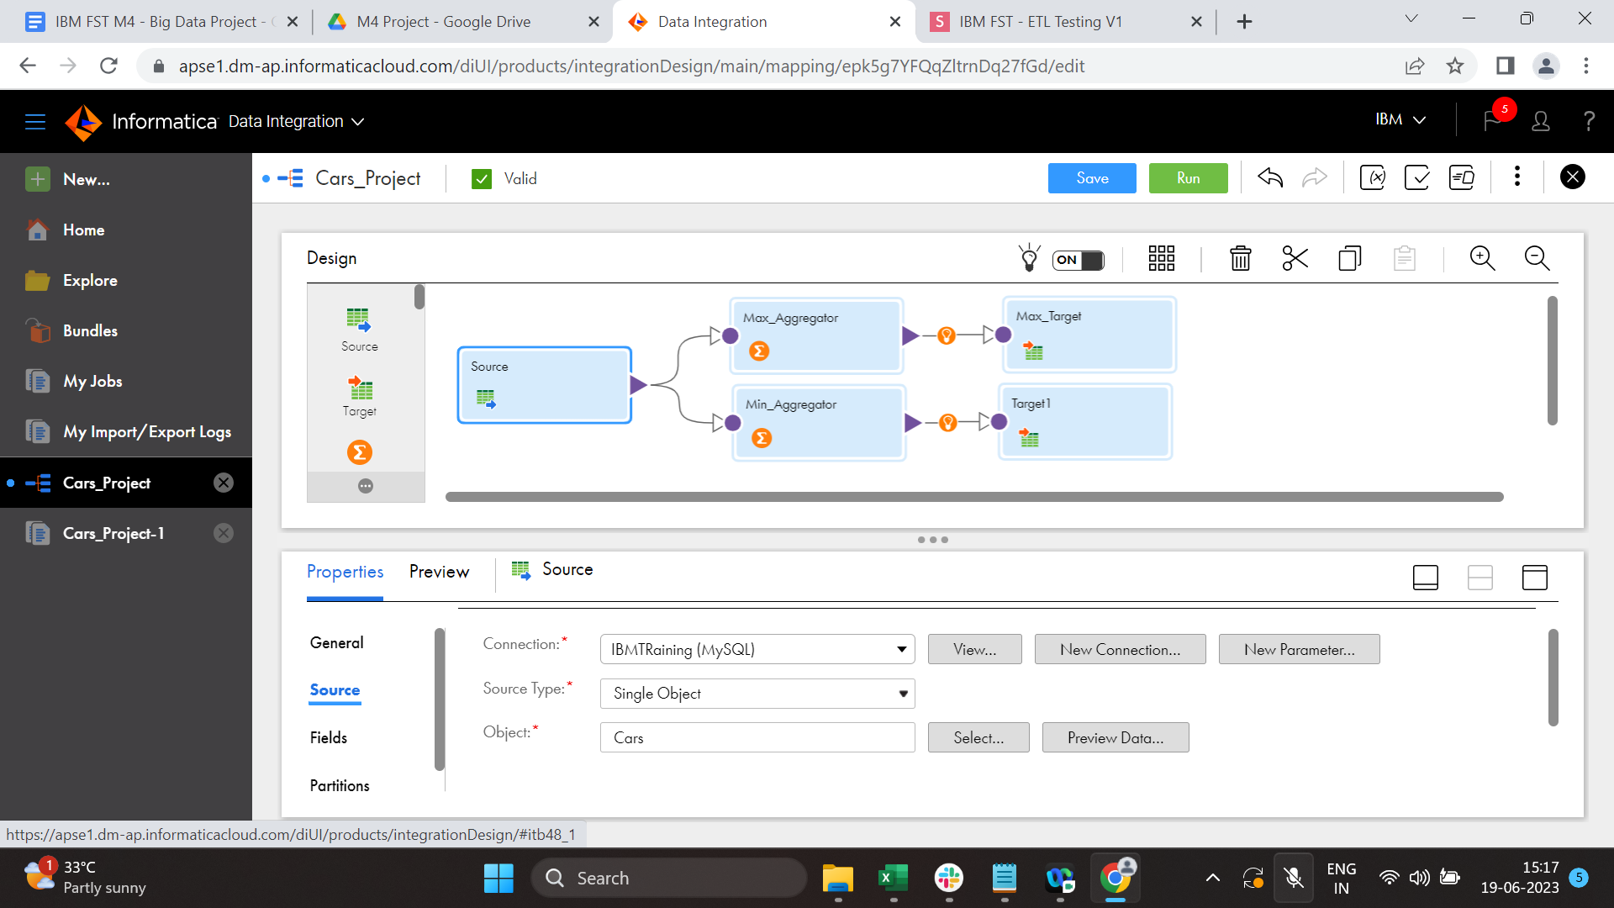

Max Aggregator:

Min Aggregator:

Max Target:

Min Target:

My Jobs:

